Name of Role | Gardening and Landscaping Volunteer

Come and volunteer at Caldmore Community Garden!
Caldmore Community Garden is a community project in the heart of Caldmore, in Walsall. We are a thriving group committed to bringing diverse communities together and making Caldmore a better place.
With the help of our volunteers, we have created a beautiful green space right in the heart of Caldmore for the whole community. Our Garden offers a safe place to relax in, for children to play in and for the community to get together at events. You can help us to develop and maintain our green space for the whole community.
- Do you have a passion for gardening or want to learn more about it?
- Would you like to make a difference to the environment in the local community?
- Do you want to share your skills and enthusiasm with other volunteers?
- Do you want to meet new people and learn new things in a friendly, welcoming environment?
- Are you looking for work experience or to enhance your CV?
If you can help, make our green space flourish - Caldmore Community Garden is the place for you!
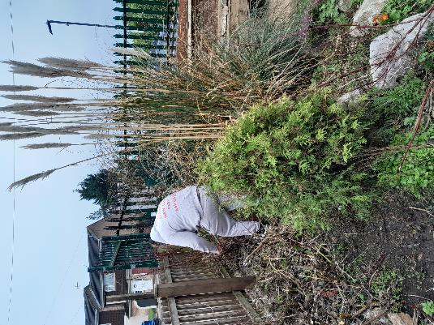
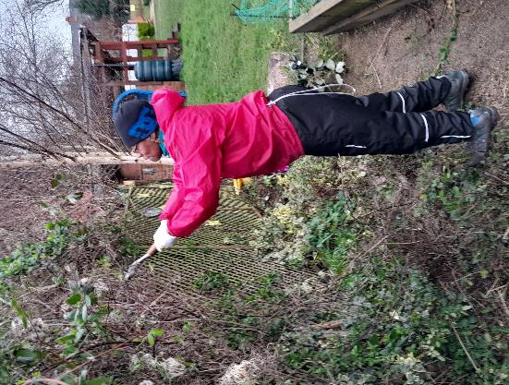
Take a look at our latest film explaining a little more about how we serve our local community: https://www.youtube.com/watch?v=vFnkR_QKRSs

Tasks – You might be asked to do any of the tasks below.

Gardening
- Plant flowers, bushes, or trees in designated spots.
- Lay down mulch or rocks to help with water retention and weed control.
- Prune and maintain existing plants as needed.
- Weed the garden beds.
- Water and maintain the area regularly to ensure the plants thrive.
- Maintain and clean gardening tools.
- Follow safety guidelines and procedures and wear any protective gear as instructed.

- Assist in other tasks as needed to support the project and team.
- Take before and after photos to track progress and share with the community.
- Enjoy and admire your hard work in creating a beautiful garden.
Landscaping
- Help with measuring and marking out for construction projects.
- Assist in preparing and organising materials and tools for the project.
- Assist with digging, mixing concrete, cutting wood or any other landscaping jobs.
- Assist in painting and finishing projects.
- Clean up and dispose of any waste properly, always taking into consideration recycling and environmental impact.
- Take before and after photos to track progress and share with the community.
Skills you will need:
- An enthusiasm for working outdoors.
- An interest in gardening and landscaping.
- A commitment to the aims of the Community Garden in wanting to improve the garden and environment of Caldmore.
- Energy and enthusiasm.
- Flexibility and adaptability.
- Ability to implement practical solutions.
- Ability to follow instructions and guidelines.

Skills you will gain:
- Practical experience of creating and maintaining a garden.
- Practical experience of landscaping.
- Working as part of a team and independently.
- Working with a wide range of people.
- Knowledge of relevant legislation.

If you want to know more about volunteering, for this role or in any other capacity, please contact us for an informal chat or text us on:
- 07384112705 (Estelle) or
- 07871813252 (Anna).

Email: caldmoregarden@gmail.com

Your help is invaluable – whatever you can contribute is always appreciated – you do not need lots of experience or to speak perfect English – this is the perfect place to learn.

