Name of Role | DIY and Construction Volunteer

Come and volunteer at Caldmore Community Garden!
Caldmore Community Garden is a community project in the heart of Caldmore, in Walsall. We are a thriving group committed to bringing diverse communities together and making Caldmore a better place.
- Do you have a passion for DIY and construction?
- Would you like to make a difference to the local community?
- Do you want to share your skills and enthusiasm with other volunteers?
- Do you want to meet new people and learn new things in a friendly, welcoming environment?
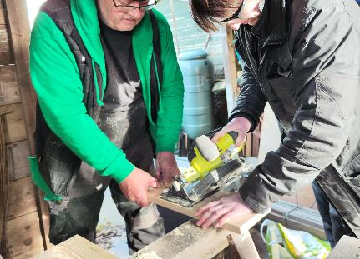
- Are you looking for work experience or to enhance your CV?

You can help us to develop and maintain our green space for the whole community. We like to create our own unique structures and art for the Garden to make it a special place for relaxing and spending time with friends and family. If you can help, make our green space totally unique - Caldmore Community Garden is the place for you!

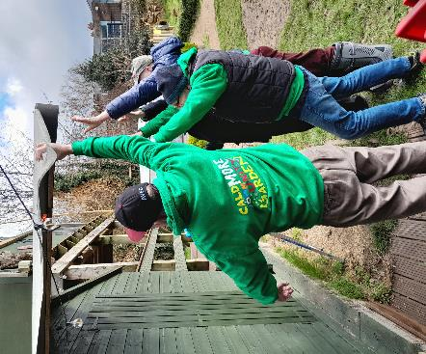

Take a look at our latest film explaining a little more about how we serve our local community: https://www.youtube.com/watch?v=vFnkR_QKRSs

Tasks - You might be asked to do any of the tasks below:
- Contribute ideas for improving the Community Garden and House environment.
- Assist in preparing and organising materials and tools for the project.
- Help with measuring and marking for construction projects.
- Assist with digging, mixing concrete, and cutting wood as instructed.
- Remove any weeds, litter, and debris from the designated area prior to starting work.
- Help install outdoor features such as a patio, walkway, play equipment etc.
- Assist in painting and finishing projects.
- Clean up and dispose of any waste properly, taking into consideration recycling and environmental impact.
- Follow safety guidelines and policies and wear appropriate protective gear.
- Assist in other tasks as needed to support the project and team.
- Take before and after photos to track progress and share with the community.
- Enjoy and admire your hard work in creating a beautiful DIY and landscaped area.
Skills you will need:
- An enthusiasm for working outdoors.
- A basic understanding of DIY and construction.
- Energy and enthusiasm.
- Flexibility and adaptability.
- Basic teamwork and collaboration skills.
- Ability to follow instructions and guidelines.

Skills you will gain:
- Practical experience of gardening and landscaping.
- Working as part of a team.
- An understanding of relevant legislation.

If you want to know more about volunteering, for this role or in any other capacity, please contact us for an informal chat or text us on:
- 07384112705 (Estelle) or
- 07871813252 (Anna).
Email: caldmoregarden@gmail.com

Your help is invaluable – whatever you can contribute is always appreciated – you do not need lots of experience or to speak perfect English – this is the perfect place to learn.

