Name of Role | Event Support Volunteer
Purpose of Role | To help deliver enjoyable, safe, and successful events at the Community Garden

Come and volunteer at Caldmore Community Garden!
Caldmore Community Garden is a community project in the heart of Caldmore, in Walsall. We are a thriving group committed to bringing diverse communities together and making Caldmore a better place.
With the help of our volunteers, we have created a beautiful green space right in the heart of Caldmore for the whole community. Our Garden offers a safe place to relax in, for children to play in and for the community to get together at events. Our events make a huge difference to the local community, helping to bring diverse groups together and helping people new to the area feel more integrated and proud of the area.
- Do you enjoy variety and experiencing new and interesting cultural events?
- Do you want to make a difference in Caldmore and help bring the local community together?
- Do you want to share your skills and enthusiasm with other volunteers?
- Do you want to meet new people and learn new things in a friendly, welcoming environment?
- Are you looking for work experience or to enhance your CV?
If you want to help us to deliver safe and successful community events that help people connect with the Community Garden and each other –
Caldmore Community Garden is the place for you!
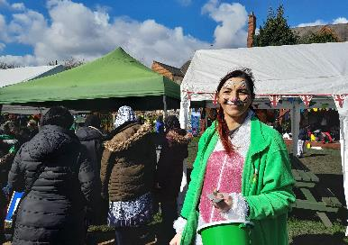
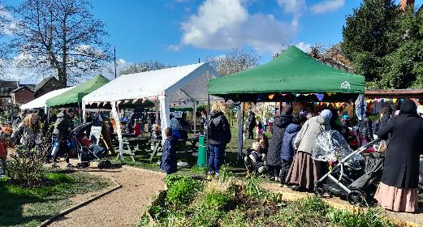

Tasks - You might be asked to do any of the tasks below:

- Contributing ideas for improving the Community Garden and House environment.
- Helping to promote the event by speaking to members of the public or distributing promotional materials.
- Helping to set up and dismantle the event space and site decorations.
- Putting up signage and event notices.
- Greeting and directing visitors and providing information about the event.
- Counting visitors in and out to ensure maximum numbers are not exceeded.
- Providing support to event staff and vendors or performing artists.
- Helping to set up a ‘Green Room’ for performers, guest speakers etc.
- Helping with stage management and music set-up.
- Helping with crowd control and ensuring a safe and enjoyable event experience.
- Assisting with food and beverage service.
- Monitoring and restocking supplies.
- Following guidelines and wearing appropriate protective gear.
- Following the relevant policies and procedures of Caldmore Community Garden (Caldmore Village Festival).
- Assist in other tasks as needed to support the project and team.
- Assisting with event clean-up and post-event activities.
- Help to take photos of the events and gain permissions to share with the community.
- Enjoy and admire your hard work in bringing about another successful event.

Skills you’ll need:
- An enthusiasm for working with communities of all backgrounds.
- A commitment to the aims of the Community Garden in wanting to build good relationships across diverse communities and helping improve the environment of Caldmore.
- Communication and interpersonal skills.
- Energy and enthusiasm.
- Flexibility and adaptability.
- Teamwork and collaboration skills.
- Ability to implement practical solutions.
- Ability to follow instructions and guidelines.

Skills you will gain:
Practical experience of planning and delivering community events.
Working as part of a team.
Working with a wide range of people.

If you want to know more about volunteering, for this role or in any other capacity, please contact us for an informal chat or text us on:
- 07384112705 (Estelle) or
- 07871813252 (Anna).

Email: caldmoregarden@gmail.com

Take a look at our latest film explaining a little more about how we serve our local community: https://www.youtube.com/watch?v=vFnkR_QKRSs

Your help is invaluable – whatever you can contribute is always appreciated – you don’t need lots of experience or to speak perfect English – this is the perfect place to learn.

