Name of Role | Playscheme Volunteer (during School Holidays)
Purpose of Role | To assist the Playscheme Leader in delivering an enjoyable, educational and safe holiday playscheme for the children attending.

Come and volunteer at Caldmore Community Garden!
Caldmore Community Garden is a community project in the heart of Caldmore, in Walsall. We are a thriving group committed to bringing diverse communities together and making Caldmore a better place.
We hold a free playscheme for local children aged 8 to 12 during the school holidays in our green space right in the heart of Caldmore. We aim to bring children together to enjoy outdoor activities, have fun while learning, get creative and messy and get to know each other.
- Would you like to make a difference to children in the local community?
- Do you want to share your skills and enthusiasm with the next generation and other volunteers?
- Do you want to meet new people and learn new things in a friendly, welcoming environment?
- Are you looking for work experience or to enhance your CV?
Caldmore Community Garden is the place for you!
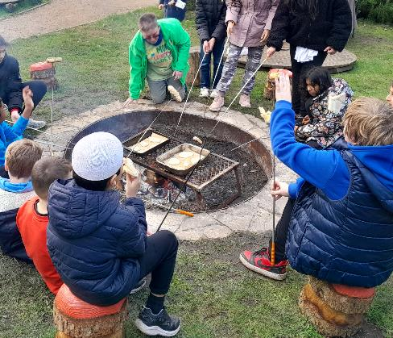

Tasks - You might be asked to do any of the tasks below:

- Arrive at the playscheme location on time and check in with the Playscheme Leader.
- Greet the children and their parents as they arrive and help to ensure a smooth transition into the program.

- Assist the Playscheme Leader to deliver play activities which may include the following:
- Supervise and help the children with craft activities, ensuring their safety and well-being at all times - e.g. checking they have the right materials, are using tools safely.
- Supervise and help the children with science experiments ensuring their safety and well-being at all times, e.g. check they are wearing the right safety protection.
- helping to prepare lunch for the children, serve meals, making sure to accommodate any dietary restrictions or allergies, and wash up afterwards.
- helping supervise children in organised and free play to ensure they are safe and enjoy the activity.
- Monitor and enforce rules and guidelines set by the Playscheme Leader to maintain a positive and inclusive environment for all children.
- Helping to prepare materials for the playscheme activities in advance and to tidy them away afterwards.
- Conducting a site check before and after the children attend to ensure there is no litter, that there are no broken bottles, protruding screws or nails or any obvious trip hazards.
- Communicate with the Playscheme Leader about any issues or concerns that may arise during the program.
- Communicating any safeguarding concerns to the safeguarding leads.
- Following all the policies and procedures of Caldmore Community Garden (Caldmore Village Festival).
- If there are any other things that you would like to do to help, please have a word with one of the managers listed above.
- Provide positive encouragement and support to the children, helping them to have a fun and memorable experience at the playscheme.

Skills you’ll need:
- An enthusiasm for working with children and families of all backgrounds.
- A clear enhanced DBS check.
- Communication and interpersonal skills.
- Patience and empathy.
- Energy and enthusiasm.
- Flexibility and adaptability.
- Teamwork and collaboration skills.
- Ability to follow instructions and guidelines.
- A basic understanding of safeguarding.
- Basic first aid knowledge (preferred but not required).
Skills you will gain:
Practical experience of working with children.
Working as part of a team.
An understanding of relevant legislation.

If you want to know more about volunteering, for this role or in any other capacity, please contact us for an informal chat or text us on:

- 07384112705 (Estelle) or
- 07871813252 (Anna).

Email: caldmoregarden@gmail.com

Take a look at our latest film explaining a little more about how we serve our local community: https://www.youtube.com/watch?v=vFnkR_QKRSs

Your help is invaluable – whatever you can contribute is always appreciated – you don’t need lots of experience or to speak perfect English – this is the perfect place to learn.

