Name of Role | Arts and Crafts Volunteer
Purpose of Role | To help in delivering arts and crafts and creative activities such as photography, art and craft activities, poetry, storytelling, sewing, and many others.

Come and volunteer at Caldmore Community Garden!
Caldmore Community Garden is a community project in the heart of Caldmore, in Walsall. We are a thriving group committed to bringing diverse communities together and making Caldmore a better place.
With the help of our volunteers, we have created a beautiful green space right in the heart of Caldmore for the whole community. We hold weekly activities where arts and crafts play a big part in maintaining a sense of wellbeing for group members as well as enhancing the Garden. We use all art forms to make the Garden a special place for relaxing and spending time with friends and family and in creating events for the whole community. You could use your creative skills in all sorts of ways to enhance our green space, to help promote and record the activities at the garden using photographs, social media or even by writing a poem.
If you would like to help make our green space truly unique and creative - Caldmore Community Garden is the place for you!
- Do you have a passion for being creative and believe that arts and crafts should be enjoyed by all?
- Do you want to make a difference in Caldmore and help bring the local community together?
- Do you want to share your skills and enthusiasm with other volunteers?
- Do you want to meet new people and learn new things in a friendly, welcoming environment?
- Are you looking for work experience or to enhance your CV?
If you want to help us to deliver creative projects, promote our activities in a unique way, help with creative activities at events or with our regular groups - Caldmore Community Garden is the place for you!

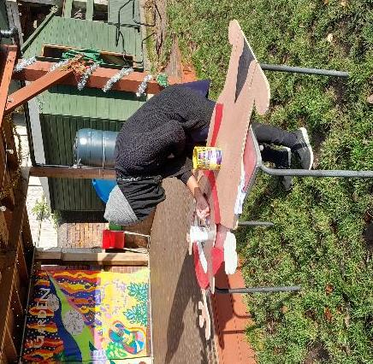
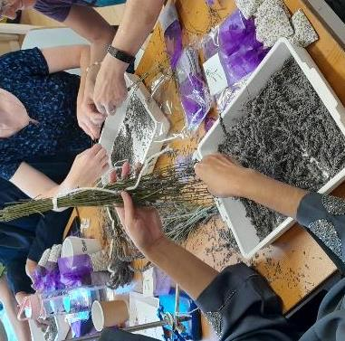
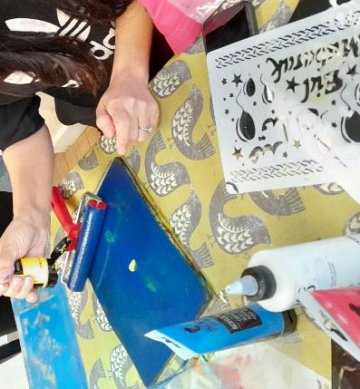
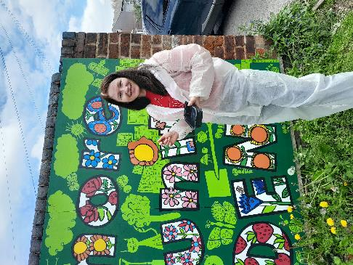
Tasks - You might be asked to do any of the tasks below:

- Contributing ideas for improving the Community Garden and House environment.
- Helping with weekly activities by setting up and tidying away and helping group members during the activities.
- Help to promote events by designing posters, social media posts and taking photographs.
- Help to take photographs of the activities and events and gain permissions to share with the community.
- Help to set up the event space and site decorations.
- Helping to make signage and event notices and put them up.
- Helping to set up a ‘Green Room’ for performers, guest speakers etc.
- Help develop and take part in large scale arts projects in the Garden (performing or visual).
- Following guidelines, policies and wearing appropriate protective gear.
- Assist in other tasks as needed, to support the project and team.
- Assisting with event clean-up and post-event activities.
- Take a moment to bask in your achievements in helping other people and bringing the community together.

Skills you’ll need:
- A passion for the arts and basic skills in your chosen creative field.
- An enthusiasm for working in a community setting with people of all backgrounds.
- Flexibility and adaptability.
- Ability to follow instructions and guidelines.
Skills you will gain:
Practical experience of working in a community setting.
Working as part of a team.
An understanding of delivering community arts and relevant legislation.
A huge sense of pride.

If you want to know more about volunteering, for this role or in any other capacity, please contact us for an informal chat or text us on:

- 07384112705 (Estelle) or
- 07871813252 (Anna).

Email: caldmoregarden@gmail.com

Take a look at our latest film explaining a little more about how we serve our local community: https://www.youtube.com/watch?v=vFnkR_QKRSs

Your help is invaluable – whatever you can contribute is always appreciated – you don’t need lots of experience or to speak perfect English – this is the perfect place to learn.

