Name of Role | Catering Volunteer
Purpose of Role | To assist in delivering healthy, tasty meals for children at our holiday playscheme and helping make the café run smoothly and profitably for our events.

Come and volunteer at Caldmore Community Garden!
Caldmore Community Garden is a community project in the heart of Caldmore, in Walsall. We are a thriving group committed to bringing diverse communities together and making Caldmore a better place.
We hold a free playscheme for local children aged 8 to 12 during the school holidays in our green space right in the heart of Caldmore. We aim to bring children together to enjoy outdoor activities, have fun while learning, and get to know each other. Sharing a nutritious meal is more than feeding the body – it feeds friendships and new experiences.
Our Community Café is open during our community events, and we serve hot and cold drinks and homemade cakes. The café helps families to socialise in the garden and helps bring in some funds to keep the Community Garden going. Our events make a huge difference to the local community, helping to bring diverse groups together and helping people new to the area feel more integrated and proud of the area.
- Do you believe children should be nurtured and given the best start in life?
- Do you want to make a difference in Caldmore and help bring the local community together?
- Do you want to share your skills and enthusiasm with the next generation and other volunteers?
- Do you want to meet new people and learn new things in a friendly, welcoming environment?
- Are you looking for work experience or to enhance your CV?
Caldmore Community Garden is the place for you!

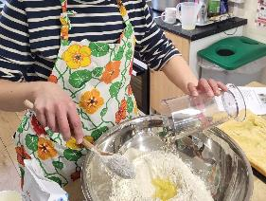
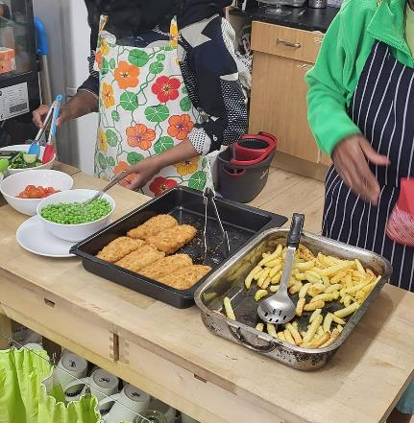
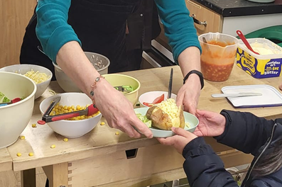
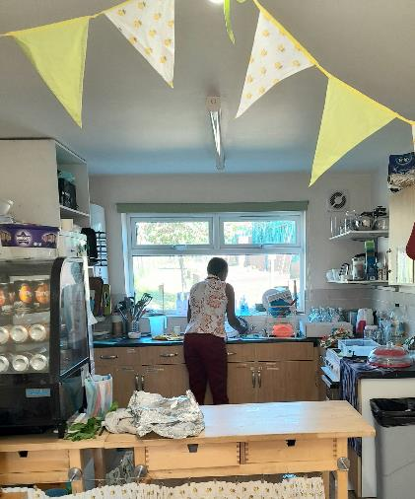

Tasks - Volunteers will be asked to do some or all of these tasks as agreed with the Playscheme Leader or Project Leader:
- Coordinate with the Playscheme Leader or Project Manager to help plan the menu for the playscheme meals and refreshments for events.
- Arrive at the Community Garden on time and check in with either the Playscheme Leader or Project Manager.
- Assist in meal preparation, including chopping vegetables, and preparing sauces.
- Set up cooking stations and equipment for the dinner service or event.
- Monitor cooking times and temperatures of dishes to ensure they are cooked properly.
- Take orders and payments for drinks and refreshments.
- Serve the meals and refreshments and provide information to ensure children and adults are able to eat within their cultural and personal preferences.
- Provide positive encouragement and support to the children to ensure they eat healthily and well.
- Maintain a clean and hygienic kitchen and dining area.
- Help keep the drinks station topped up with milk, sugar, squash, and clean spoons.
- Assist in cleaning up and clearing tables during and after the event.
- Help to keep bins empty and the toilet stocked with consumables.

Skills you’ll need:
- An understanding of food hygiene and food preparation.
- An enthusiasm for working with children and communities of all backgrounds.
- Communication and interpersonal skills.
- Energy and enthusiasm.
- Flexibility and adaptability.
- Teamwork and collaboration skills.
- Willingness to undertake food safety training.
- Ability to follow instructions, policies, and guidelines.
Skills you will gain:
- Practical experience of preparing and serving meals and refreshments.
- Working as part of a team.
- Customer service skills.
- Knowledge of relevant legislation and good practice.
- A huge sense of pride in helping your community.

If you want to know more about volunteering, for this role or in any other capacity, please contact us for an informal chat or text us on:
- 07384112705 (Estelle) or
- 07871813252 (Anna).

Email: caldmoregarden@gmail.com

Take a look at our latest film explaining a little more about how we serve our local community: https://www.youtube.com/watch?v=vFnkR_QKRSs

Your help is invaluable – whatever you can contribute is always appreciated – you don’t need lots of experience or to speak perfect English – this is the perfect place to learn.

