Name of Role | Administration Volunteer
Come and volunteer at Caldmore Community Garden!
Caldmore Community Garden is a community project in the heart of Caldmore, in Walsall. We are a thriving group committed to bringing diverse communities together and making Caldmore a better place.
With the help of our volunteers, we have created a beautiful green space right in the heart of Caldmore for the whole community. Our Garden offers a safe place to relax in, for children to play in and for the community to get together at events. Our events make a huge difference to the local community, helping to bring diverse groups together and helping people new to the area feel more integrated and proud of the area. We can’t achieve all this without good planning, monitoring, and administration!
- Do you want to make a difference in Caldmore and help bring the local community together?
- Do you want to share your skills and enthusiasm with other volunteers?
- Do you want to meet new people and learn new things in a friendly, welcoming environment?
- Are you looking for work experience or to enhance your CV?
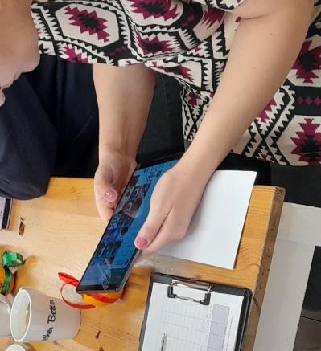
If you think good administration is key to helping the community connect with the Community Garden and each other - Caldmore Community Garden is the place for you!
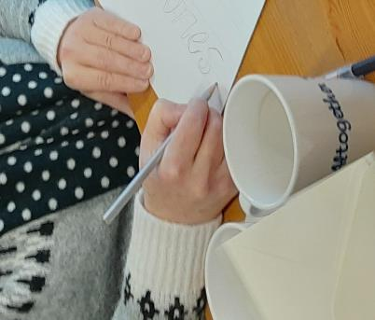

Take a look at our latest film explaining a little more about how we serve our local community: https://www.youtube.com/watch?v=vFnkR_QKRSs

Tasks - You might be asked to do any of the tasks below:

- Helping to update mailing lists by inputting addresses to Mailchimp.
- Inputting phone numbers to circulation lists.
- Sending messages to volunteers and the public via social media.
- Assisting with producing information such as posters, notices and newsletters using Microsoft Word.
- Helping to obtain quotations for goods or services via email or telephone.
- Helping to maintain financial records by attaching receipts in QuickBooks,
- Using Microsoft Excel to keep existing spreadsheets up to date with monitoring information.
- Filing documents.
- Counting and reconciling cash records.
- Following all the policies and procedures of Caldmore Community Garden (Caldmore Village Festival).

Skills you’ll need:
- A good understanding of English and Maths.
- A basic knowledge of the use of IT including Word, Excel and using social media.
- Communication and interpersonal skills.
- An eye for detail.
- Flexibility and adaptability.
- Teamwork and collaboration skills.
- Ability to follow instructions and guidelines.
Skills you will gain:
- Practical experience of administration and basic bookkeeping.
- Working as part of a team.
- An understanding of relevant legislation such as data protection and copyright.
- Pride in the role you’ve played in bringing communities together!

If you want to know more about volunteering, for this role or in any other capacity, please contact us for an informal chat or text us on:
- 07384112705 (Estelle) or
- 07871813252 (Anna).
Email: caldmoregarden@gmail.com

Your help is invaluable – whatever you can contribute is always appreciated – you don’t need lots of experience or to speak perfect English – this is the perfect place to learn!

