Name of Role | Social media and Publicity Volunteer
Come and volunteer at Caldmore Community Garden!
Caldmore Community Garden is a community project in the heart of Caldmore, in Walsall. We are a thriving group committed to bringing diverse communities together and making Caldmore a better place. The Garden is a relaxing and safe space to meet up with existing friends and make new friends from different communities.
Caldmore Community Garden makes a huge difference to the local community, helping to bring diverse groups together and helping people new to the area feel more integrated and proud of the area. If you want to help us to get the message out and help people connect with the Community Garden and each other - Caldmore Community Garden is the place for you!
- Do you want to share your skills and enthusiasm for social media to help promote Caldmore Community Garden?
- Would you like to make a difference to the local community?
- Do you want to meet new people and learn new things in a friendly, welcoming environment?
- Are you looking for work experience or to enhance your CV?
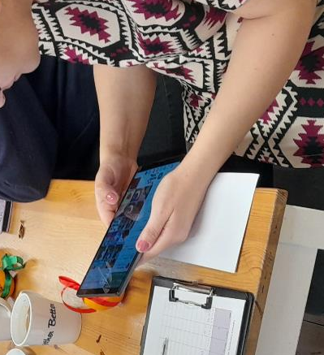
Tasks - You might be asked to do any of the tasks below:
- Help to research and identify relevant online communities, forums, and social media channels to engage with our target audience.
- Create and schedule social media posts to promote our community events and regular activities including Facebook, Instagram, and WhatsApp.
- Help to monitor and report or respond to comments, messages, and mentions on social media platforms.
- Develop relationships with other Community organisations to increase visibility and reach.
- Help to write and distribute press releases to local media outlets.
- Assist with planning and coordinating internal training.
- Track and report on social media metrics and engagement performance.
- Help draft and schedule e-mail and printed newsletter campaigns.
- Collaborate with the Project Manager and Volunteer and Community Engagement Worker to create social media content calendars and campaigns.
- Stay up to date on social media trends and best practices.
- Take photographs and help document Garden activities.
- Assist with any additional tasks as needed to support Caldmore Community Garden’s social media and publicity efforts.
Skills you’ll need:
- An enthusiasm for working with the local community.
- Good IT skills and knowledge of social media platforms.
- Communication and interpersonal skills.
- Energy and enthusiasm.
- Flexibility and adaptability.
- Teamwork and collaboration skills.
- Ability to follow instructions and guidelines.

Skills you will gain:
Practical experience of promoting community projects through a variety of social media and media channels.
Working as part of a team.
An understanding of relevant legislation.

If you want to know more about volunteering, for this role or in any other capacity, please contact us for an informal chat or text us on:
- 07384112705 (Estelle) or
- 07871813252 (Anna).

Email: caldmoregarden@gmail.com

Take a look at our latest film explaining a little more about how we serve our local community: https://www.youtube.com/watch?v=vFnkR_QKRSs

Your help is invaluable – whatever you can contribute is always appreciated – you don’t need lots of experience or to speak perfect English – this is the perfect place to learn.

